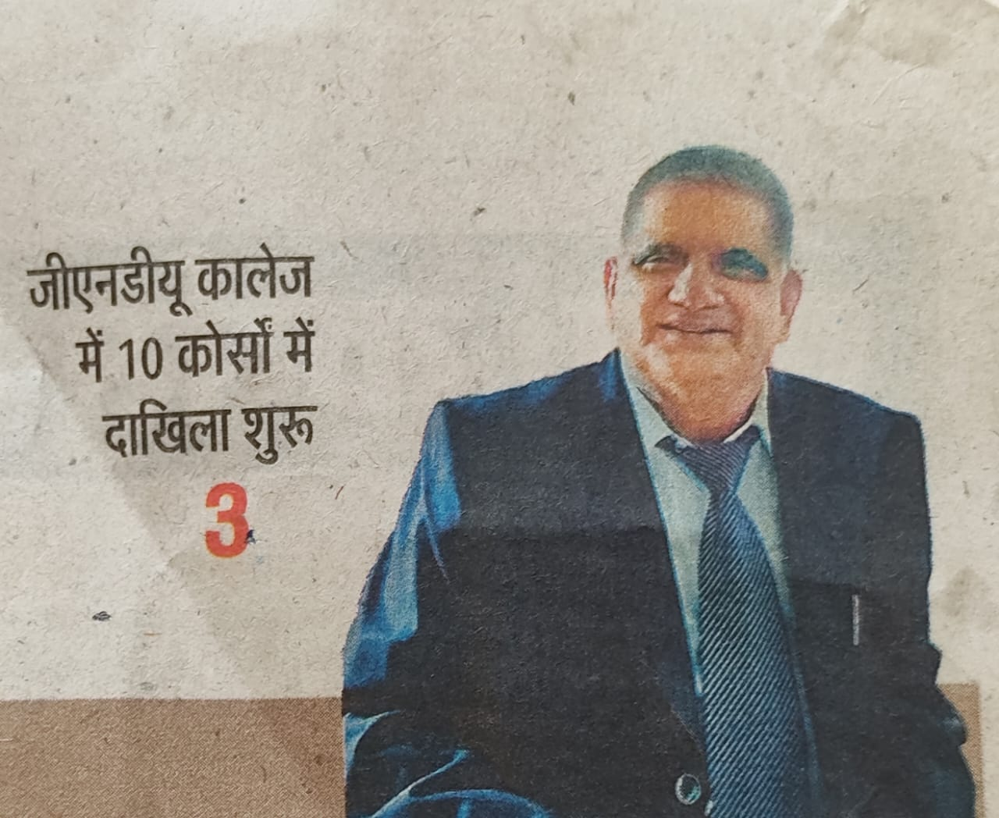

While I welcome you all to holy precincts of our institution named Guru Nanak Dev University College Sujanpur, I, along with all faculty members, am excited to meet you one by one our mutual enrichment. Having spent more than 45 years in the field of Higher Education, I have come to realize the value of collaboration, compassion, and consideration for everyone under the sky and on the earth. Teaching and learning go side by side and we are all duty bound to hold each other's hands making our institution a much sought after centre of learning. Yet another thought comes to my mind. It pertains to the current unbearable heat of the scorching sun. To this issue, we need to rise up for making eco-friendly activity a part of our day-to-day routine. Let us begin by planting more and more trees, entering the domain of paperless communication, and by promoting flora and fauna around us.